**COMPONENTES**

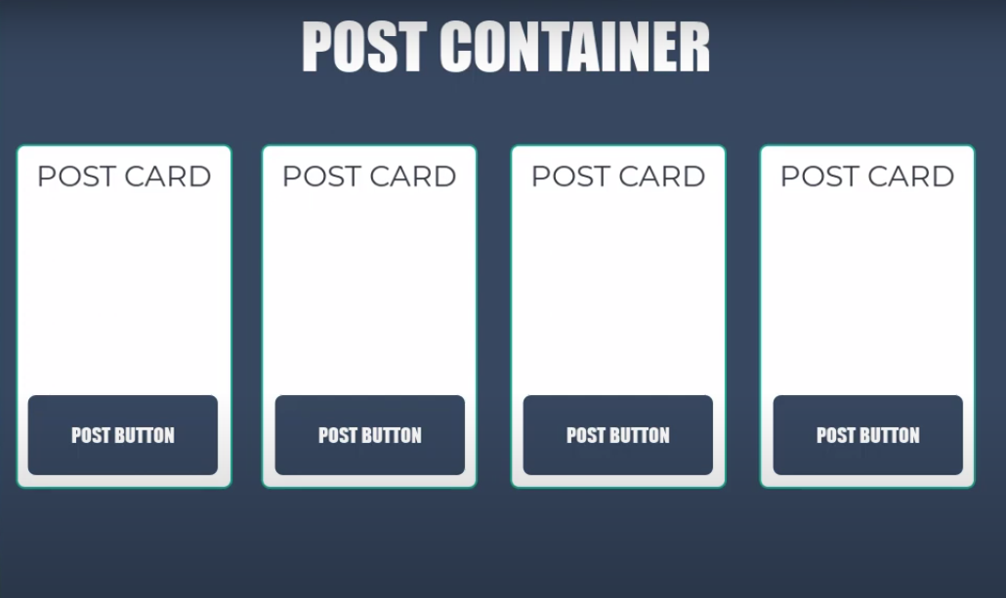

CREACIÓN DE LOS COMPONENTES

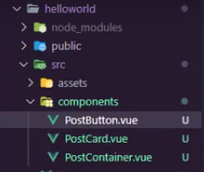

PostButton.vue

<template>

<button class="post-btn">ACCEDER</button>

</template>

<script lang="ts" setup>

</script>

<style scoped>

.post-btn{

    padding: 0;

    background-color: blueviolet;

    color: white;

    border: 0;

    outline: 0;

}

.post-btn:hover{

    background-color: white;

    color: blueviolet;

}

</style>

PostCard

<template>

<div class="post-card">

    <h3>Título</h3>

    <p>Lorem ipsum dolor sit amet consectetur adipisicing elit. Voluptatem corrupti voluptas, ad velit numquam qui eaque dolor nam ratione voluptates laboriosam vel laudantium nobis necessitatibus consequatur doloribus illo vero nesciunt!</p>

    <PostButton />

</div>

</template>

<script lang="ts" setup>

    import PostButton from './PostButton.vue';

</script>

<style scoped>

.post-card{

    border-radius: 15px;

    padding: 10px;

    margin: 5px;

    border: 1px solid #ccc;

}

</style>

PostContainer

<template>

    <div class="post-container">

        <PostCard />

        <PostCard />

        <PostCard />

        <PostCard />

    </div>

</template>

<script lang="ts" setup>

import PostCard from './PostCard.vue';

</script>

<style>

.post-container{

    width: 100%;

    display: flex;

    flex-wrap: wrap;

}

</style>

**OPTION API VS COMPOSITION API**

**PRIMEROS PASOS CON OPTION API**

<template>

    <h3>{{ counter }}</h3>

    <button @click="addCounter">Incrementar</button>

</template>

<script lang="ts" >

    import { defineComponent } from 'vue';

    export default defineComponent({

        name: 'CounterOption',

        components: {},

        data(){

            let counter =0;

            return {counter}

        },

        methods: {

            addCounter(){

                this.counter++;

            }

        },

    })

</script>

<style>

</style>

**PRIMEROS PASOS CON COMPOSITION API**

<template>

    <h3>{{ counter }}</h3>

    <button @click="addCounter">Incrementar</button>

</template>

<!-- <script lang="ts">

    import { defineComponent } from 'vue';

    export default defineComponent({

        name: 'CounterComposition',

        setup(){

            let counter =0;

            const addCounter = () => {

                counter++;

                //console.log(counter);

            }

            return {counter, addCounter}

        },

    })

</script> -->

<!-- TENIENDO EN CUENTA QUE HAY QUE AGREGAR LA REFERENCIA EN JS -->

<!-- <script lang="ts">

    import { defineComponent, ref } from 'vue';

    export default defineComponent({

        name: 'CounterComposition',

        setup(){

            let counter =ref(0);

            const addCounter = () => {

                counter.value++;

                //console.log(counter);

            }

            return {counter, addCounter}

        },

    })

</script> -->

<script lang="ts" setup>

import { Ref, ref } from 'vue';

let counter: Ref = ref(0);

const addCounter = (): void => {

    counter.value++;

}

</script>